

Savonius
H-Rotor

VAWT

Qena STEM school
Grade 10
Semester 2
Group #23110

Team members



Emad Ahmed Fathi Ahmed
Email: Emad.2324027@stemqena.moe.edu.eg
ID:2324027
Role: Leader



philopateer Nabil Aziz Soliman
Email: philopateer.2324039@stemqena.moe.edu.eg
ID: 2324039
Role: Researcher



Ahmed Hassan Mahmoud Mohamed
Email: Ahmed.2324004@stemqena.moe.edu.eg
ID: 2324004
Role: Presenter


Mohamed Shawky Mohamed Mohamed
Email:Mohamed.2324049@stemqena.moe.edu.eg
ID: 2324049
Role: Recorder

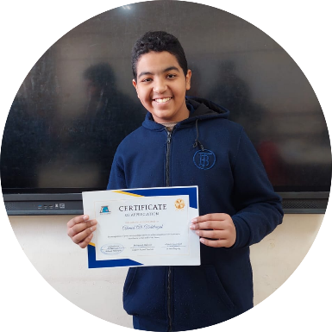
Ahmed Ali Abdelrigal Hassan
Email:Ahmed.2324006@stemqena.moe.edu.eg
ID: 2324006
Role: Facilitator

Table of contents
I. Present and Justify a Problem and Solution Requirements
- Egypt’s Grand Challenges.
- If problem to be/NOT solved.
- Research
- Other solution already tried (prior solution)

II. Generation and defending a solution
- Solution and design requirements
- Selection of solution
- Selection of prototype

III. Constructing and Testing a Prototype
- Materials and Methods
- Test plan
- The safety precautions
- Data collection
- Results

IV. Evaluation, Reflection, Recommendations Analysis and Discussion
- Analysis and Discussion
- Conclusion
- Recommendation
- Learning Outcomes
- Literature cited

Introduction
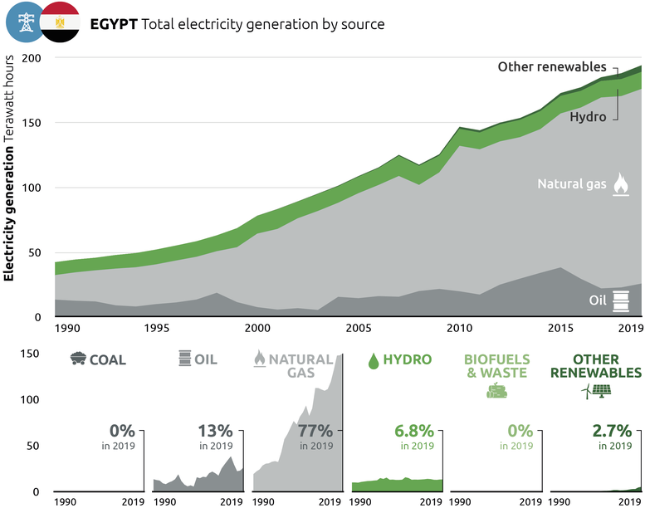
Egypt is facing multiple national challenges that threaten its development, economy, and environment. One of the most urgent issues is the country’s high reliance on non-renewable energy sources. Over 90% of Egypt’s electricity production still depends on oil and natural gas. These fossil fuels are limited, expensive to extract, and produce harmful emissions that increase air pollution and accelerate climate change. This situation affects millions of people, especially in cities like Cairo, where air quality is far below World Health Organization safety standards.
Fig.1
Our Capstone project addresses this issue by proposing a simple, efficient, and sustainable solution: a hybrid vertical axis wind turbine (VAWT). The turbine combines two types of rotors which are Savonius and H-rotor to work effectively under different wind conditions. The Savonius rotor is drag-based and allows the system to self-start at low wind speeds. The H-rotor uses lift force to increase speed and efficiency at higher wind speeds. Together, these components ensure consistent energy production.
We chose to build the system using recycled materials such as PVC, acrylic, and scrap aluminum to reduce cost and environmental impact. The energy produced is stored in a lithium-ion battery to make it usable even when the wind is not blowing. The design fits within a compact size limit of 0.5 m³ and complies with all school safety and Capstone rules.
The engineering design process guided every stage of our work—from problem research and solution selection to testing and evaluation. This project supports Egypt’s shift toward renewable energy, promotes innovation, and shows how students can develop practical solutions for national challenges. It also reflects our commitment to sustainability, technology, and teamwork in tackling real-world problems.

- Present and Justify a Problem and Solution Requirements

Egypt’s Grand Challenges
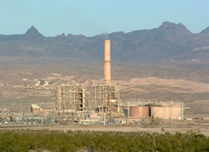
- Increasing of reliance on alternative energy
Egypt faces a lot of challenges, that making the search for new and renewable energy sources essential for sustainable development. Currently, Egypt relies on non-renewable sources like oil and natural gas for approximately 90% of its energy needs. However, as these resources are not recoverable, and their environmental impact grows with more usage; shifting to alternative energy has
Fig.2
become necessary to reduce dependence on fossil fuels and promote sustainability.

So, what is Alternative Energy?
Alternative or renewable energy comes from natural sources that do not run out and have minimal impact on the environment. These sources include solar, wind, and hydropower, which don’t produce harmful emissions and help protect the environment. Currently, renewable energy makes up only 10% of Egypt’s total energy production, but this percentage is expected to rise with more investment in the sector.
Comparison renewable and nonrenewable resources Solar Energy:
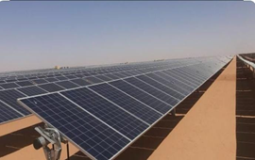
Pros:
- Eco-friendly with no harm
- fuel emissions.
- Egypt benefits from 2,400–3,000 hours of sunlight annually
- Helps reduce dependence on fossil fuels.

Cons:
Fig.3
- High initial installation costs.
- Efficiency depends on weather conditions and daylight hours.
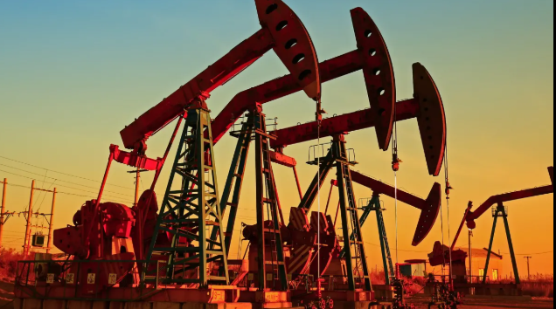
Petroleum:
Pros:
- Provides high energy output and efficiency.
- Supported by a well-established infrastructure.
Cons:
- Causes pollution and greenhouse gas emissions.
- Non-renewable and becoming more expensive over time.
Fig.4
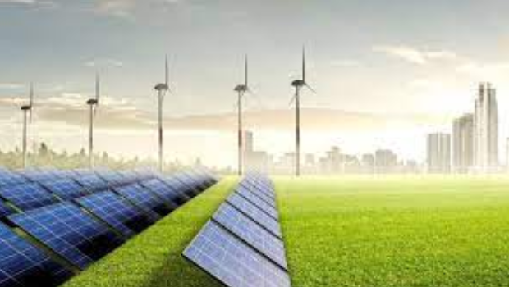
Increasing reliance on alternative energy is crucial for Egypt’s economic and environmental future. While challenges like cost and infrastructure exist, the long-term benefits outweigh them. As data suggests, switching to renewable energy will help reduce carbon emissions, improve energy security, and support sustainable development. Investing in clean energy today will ensure a greener and more stable future for future generations.
Fig.5

B. Climate change
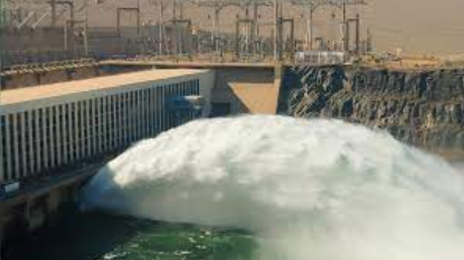
Climate change has a major impact on Egypt’s energy sector. One clear example is the effect on hydroelectric power plants along the Nile River. As temperatures rise and droughts become more frequent, water levels decrease, making it harder for these plants to produce electricity. This also affects irrigation, putting agriculture and water supply at risk.
Fig.6
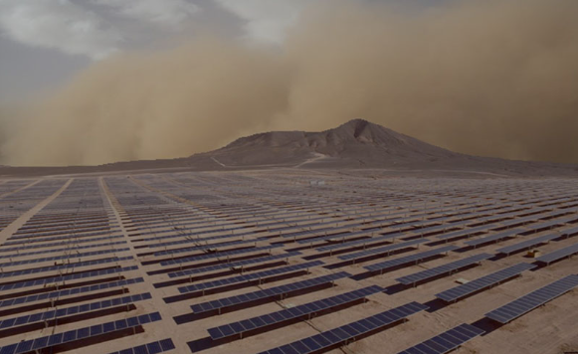
The heavy use of fossil fuels in industries and transportation adds to the problem by causing air pollution and acid rain, which damages soil and reduces crop production. At the same time, rising temperatures lead to higher evaporation rates, drying out the land and making it less fertile. As people rely more on electricity for cooling, energy demand increases. This leads to burning more fossil fuels, which releases more greenhouse gases, making climate change even worse.
Fig.7
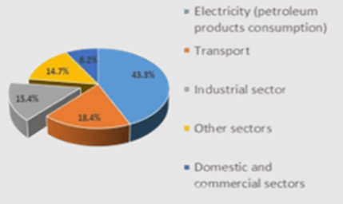
The pie chart illustrates the distribution of petroleum product consumption in Egypt across different sectors. The electricity sector accounts for the largest share at 43.3%, followed by the transport sector at 18.4%, highlighting the heavy reliance on fuel for vehicle operation. The industrial sector consumes around 15.4%, while other sectors account for 14.7%. Domestic and commercial use represents only 8.2% of total consumption. These figures emphasize the need to promote renewable energy to reduce dependence on fossil fuels
Graph.1
Renewable energy is a great alternative, but it also has some challenges. Sandstorms and strong winds can cover solar panels with dust, reducing their efficiency and increasing maintenance costs. However, new cleaning technologies and better designs can help solve these issues, making renewable energy a strong option for Egypt’s future.
Switching to cleaner energy sources is essential to reduce the effects of climate change and secure a more stable and sustainable energy future.

- Improving technology for everybody
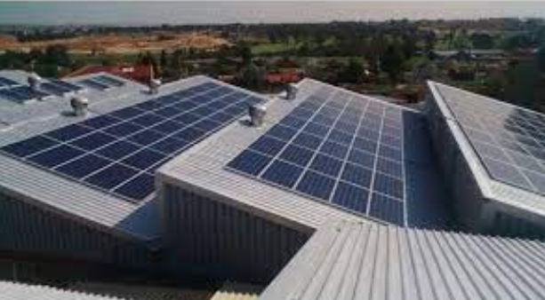
Egypt has a good history and great location, but it still has some major problems in its industry that delay economic growth. Even though it has all the elements of success, problems like pollution and lack of skilled labor force hamper growth. These problems need to be resolved for long-term development.
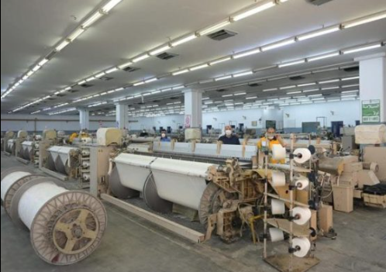
The majority of factories still use old machinery, which makes production more expensive and reduces the quality of goods. This makes them uncompetitive. Second, Egyptian industries use huge amounts of electricity, but power outages and expensive prices regularly stop production and increase costs. The use of alternative energy can help reduce costs, reduce pollution, and provide a stable electricity supply to factories.
Fig.8
Burning fossil fuels in factories also generates a lot of pollution, which is not healthy for humans. Technological change, the development of infrastructure, and the use of clean energy can help factories become more efficient, more attractive to investment, and make Egypt's industry stronger and more competitive.
Fig.9
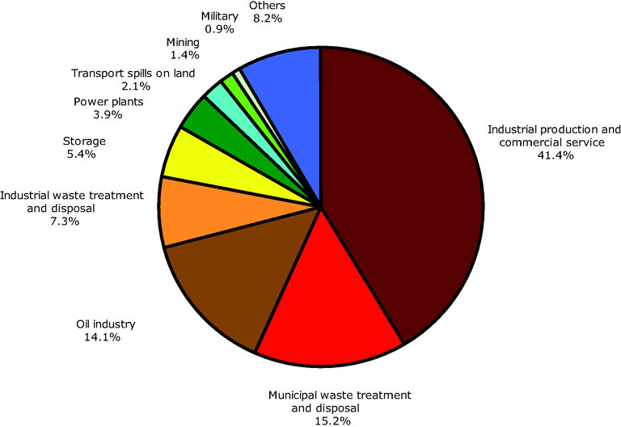
If Egypt starts using alternative energy in its industries, it will need less expensive traditional energy, which will lower production costs and improve product quality. There will be less pollution, which means cleaner air and better health for people. Also, new energy projects will create more jobs, support new ideas, and bring in foreign investors. In the end, Egypt will have strong and sustainable industrial growth and a better place in the world economy.
Graph.2
- increasing work opportunity in Egypt
Generating new job opportunities in Egypt is required to maintain the economy and improve the standard of living, especially since a vast number of people are unemployed. At the same time, factories and businesses require new energy sources to run efficiently and increase productivity.
Development of the use of alternative or renewable energy can be a solution to two problems. First, it can provide sustainable energy to power factories and achieve economic and industrial growth. The second benefit is the creation of new job opportunities in different fields, such as the operation of wind turbine and solar energy plants, and maintenance of the plants.
Unemployment in Egypt
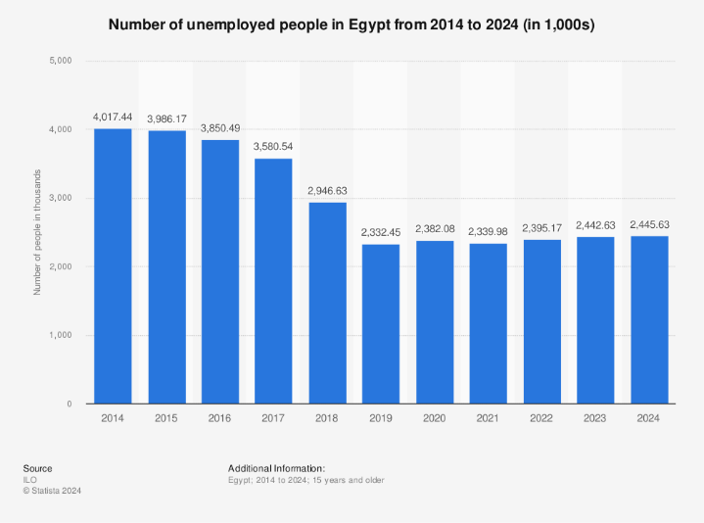
The graph illustrates the amount of Egyptians that have been unemployed since 2014 up to 2024. Although the number dropped, there are many that are still unemployed. The reason for this is that there is not sufficient power in the factories to grow and expand personnel.

How Does Renewable Energy Create Jobs?
Graph.3
Additional jobs can be created by renewable energy. Egypt is already doing so. As can be viewed from the graph, wind energy has been giving jobs to about 4,200 people, and solar energy has been giving jobs to about 2,100 people.
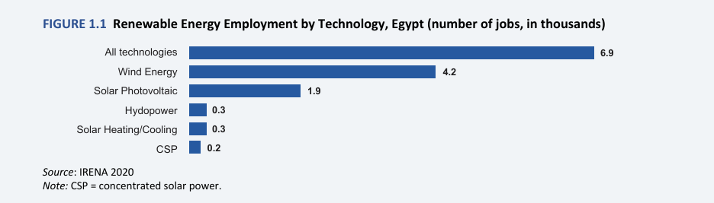

Graph.4
This was because Egypt focused on the use of clean energy, which provided many with employment. The country is still trying to expand this, and jobs are being created day by day. People are now in a position to work in solar power stations, wind stations, and energy system maintenance.

- Pollution
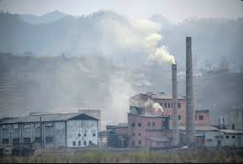
Pollution is a big problem in Egypt. It affects people’s health, the economy, and the environment. According to the World Bank, Egypt loses about $47 billion every year because of diseases and pollution. Big cities like Cairo and Alexandria have very dirty air because of car smoke, factories, and burning garbage. The air pollution is much higher than the safe limit set by the World Health Organization.
Fig.10

Egypt also has water pollution, especially in the Nile River, which is the main source of water. Every year, about 4.5 billion cubic meters of dirty water go into the Nile from factories, farms, and sewage. This pollution harms people’s health, farming, and fish.
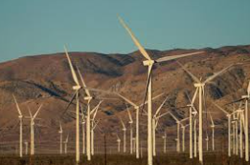
To solve these problems, renewable energy, like solar and wind power, is a great solution. Egypt has a lot of potential in this area. For example, the "Benban" solar project in Aswan is one of the biggest solar energy projects in the world. It produces 1.8 gigawatts of electricity. There are also wind energy projects, like "Gabal El-Zeit," which produces 580 megawatts of clean electricity. These projects reduce the use of polluting fuels and make the air cleaner. Using renewable energy helps improve air quality, reduces diseases from pollution, and protects the environment for future generations. It also creates new jobs and supports the economy. Investing in clean energy is not just good for the environment, but also a great opportunity for growth and development.
Fig.11

Problem to be solved
Climate change is a big problem for Egypt and solving it will have a very positive effect on many areas, including the environment and the economy. Heat waves will become less extreme, and temperatures will be more stable, which will help crops grow better. Reducing climate change will also help stop the risks of floods and droughts. In addition, it will improve the quality of air and water, leading to better health for people and reducing diseases caused by pollution.

Alternative energy is one of the best clean solutions and using it more widely will reduce Egypt's dependence on fossil fuels in both industry and daily activities. It will also lower the economic costs of importing or extracting natural gas and oil. In addition, using alternative energy will reduce harmful gas emissions, which will have a positive impact on public health.

Egypt has many areas rich in renewable energy sources, such as the Western Desert and the Gulf of Suez. This means that if Egypt relies on producing alternative energy, it could become one of the largest energy exporters in the region. This would strengthen its economy and attract more investments.

If pollution in Egypt would disappear, water and air would be cleaner, so individuals would be healthier, and life would be easier. Agriculture would become better with clean water, and using renewable energy would be less expensive and offer new opportunities for employment. Towns would be cleaner and more enjoyable, tourism would emerge, and everybody's future would be brighter

If problems are solved
1. Reducing depends on fossil fuels.
2. Improving health and reducing pollution.
3. Developing industry and increase productivity.
4. Creating new job opportunities.
5. Improving of quality of life.
6. Improving Agriculture and security.
7. Boosting Eco-tourism.
8. Reducing environmental ricks and natural disasters.
9. Technological progress boosting the economy.
10. Less pollution, health and sustainable environment.

If problems are not solved:
- Continued reliance on fossil fuels and energy crises.
- Worsening pollution and health problems
- Weak industrial growth and low productivity.
- Rising unemployment and fewer job opportunities.
- Declining quality of life.
- Weak agriculture and increased food insecurity.
- Decline in eco-tourism.
- Higher environmental risks and more natural disasters.
- Slower technological progress and weaker economy.
10.Severe pollution with long-term environmental and health impacts.

Research
Topic for researching the problem:
1. Fossil Fuel Depletion in Egypt
2. Energy Access in Rural and Isolated Areas
3. Urban Air Pollution from Conventional Power Plants
4. Climate Change Impacts on Egypt
5. Low Renewable Energy Adoption Rates
6. Unstable Wind Energy Production in Urban Settings
7. Inefficient Wind Turbine Designs for Low-Speed Winds
8. Waste from Mass-Produced Turbines and Blades
9. Lack of Affordable, Scalable Microgeneration Systems
10. Mismatch Between Energy Production and Storage
Topic for researching the solution:
- Savonius Rotor Design Principles
- H-Rotor (Darrieus-type) Mechanics
- Hybrid Rotor Synergy
- Small-Scale Wind Turbine Efficiency
- Wind Energy Conversion Components
- Electrical Energy Storage Systems
- Environmental and Cost Criteria for Blade Materials
- Output Measurement Techniques
- Wind Simulation for Prototype Testing
10Turbine Stability and Mounting System
Prior solutions
“Other solutions already tried”

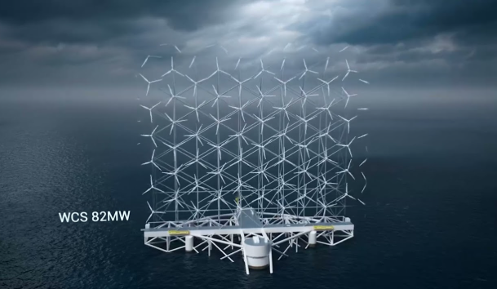
Norwegian Floating Vertical Wind Turbines
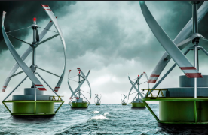
With the world turning towards renewable energy, offshore wind power is emerging as a key component of sustainable electricity production. But conventional horizontal-axis wind turbines (HAWTs) are limited in deep waters, where installation is expensive and complicated. To overcome this limitation, Norwegian firm Worldwide Wind is leading the way in the creation of floating vertical-axis wind turbines (VAWTs)—a revolution any solution tailored for deep-sea deployment.
Fig.12

In contrast to conventional turbines, these offshore VAWTs are optimized to harness strong and consistent offshore winds with greater efficiency and smaller environmental impact. By dispensing with the need for fixed seabed foundations, they provide vast new areas for the harvesting of wind power, allowing offshore wind farms to be more scalable and flexible.
Fig.13

Advantages Norwegian Floating Vertical Wind Turbines
1.Enhanced Utilization of Offshore Space: VAWTs allow for closer mounting without sacrificing performance or generating turbulence, leading to increased energy in wind farms.
2.Lower Upkeep Expenses: With heavy components situated close to the water surface, service and repair become more accessible and less costly than conventional deep-ocean turbines.
3.Deep-Water Operation: Unlike traditional fixed-bottom turbines, floating VAWTs are capable of operating in deep-sea locations where winds are more stable and stronger.

4.Less Wake Effect: The vertical-axis design minimizes turbulence between turbines, improving the overall efficiency of wind farms.
5.Scalability and Transportability: Floating turbines can be constructed and assembled onshore and then transported and installed in deep-sea locations, simplifying logistics.

Disadvantages Norwegian Floating Vertical Wind Turbines
1.Technology Still in Development: Floating VAWTs remain in the initial research and proof stages, and their mass-scale commercial feasibility is still to be proven.
2.Structural and Mechanical Complexity: The turbines must withstand extreme marine conditions, including high winds, sea currents, and corrosion, and thus require advanced materials and engineering.
3.High Upfront Cost: Development, research, and installation demand substantial investment, making early adoption a financial challenge.
4.Difficult Grid Integration: Offshore floating wind farms require sophisticated subsea cabling to transfer electricity economically onto the coast, adding infrastructure costs.
5.Market and Investor Hesitation: Investors favor tested and proven wind technologies, which slows down the adoption of this innovative approach.
6.Uncertain Environmental Impact: While promising, further research is needed to understand how floating VAWTs affect marine ecosystems, underwater noise levels, and wildlife habitats.

- Nabq Island in South Sinai:
In South Sinai Governorate, specifically on Nabq Island in Sharm El-Sheikh, the largest solar power station has been instrumental in making Sharm El-Sheikh Egypt’s first green city, aligning with the COP27 Climate Conference and Egypt’s renewable energy goals.
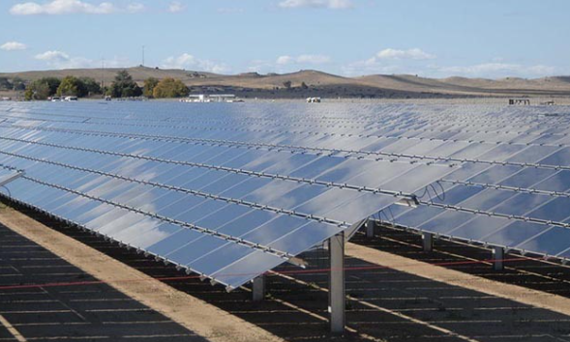
Spanning 250,000 square meters, the Nabq Solar Power Station was inaugurated in October 2022 with an investment of 250 million EGP ($10.3 million) by TAQA Photovoltaic Energy Company. It has a production capacity of 42 GWh annually and operates under a self-consumption system managed by Global Energy, a subsidiary of Arab Energy.
The station supplies 30% of Nabq Island’s electricity and powers 6,000 hotel rooms with clean energy. Over its 25-year lifespan, it is expected to cut carbon emissions by 500,000 tons, significantly aiding environmental conservation.
Advantages of Nabq Solar Power Station:
1. Renewable Energy Source: Solar power is a sustainable energy solution that reduces reliance on fossil fuels.
2. Reduction in Carbon Emissions: The station plays a key role in Egypt’s environmental initiatives by lowering greenhouse gas emissions.
3. Support for Green Tourism: By supplying clean energy to hotels, the project promotes eco-friendly tourism in Sharm El-Sheikh.
Fig.14

4. Energy Independence: The station enhances Egypt’s energy security by providing a stable and locally sourced power supply.
5. Long-Term Cost Savings: While the initial investment is high, solar energy reduces long-term electricity costs by minimizing dependence on non-renewable sources.

Disadvantages of Nabq Solar Power Station:
1. High Initial Cost – The setup expenses, including solar panels, inverters, batteries, and installation, are substantial.
2. Weather Dependence – Solar panels require sunlight, making them less efficient on cloudy or rainy days and completely inactive at night.
3. Expensive Energy Storage – Storing solar energy in batteries for nighttime use is costly, often making grid electricity a more practical alternative.
Fig.14

4. Large Space Requirement – Solar panels need significant space, which may not always be available on rooftops, requiring additional land.
5. Environmental Concerns – Although solar energy is clean, manufacturing and disposing of solar panels involve emissions and hazardous materials, necessitating proper waste management.
- The Sharm El-Sheikh Wind Turbine:
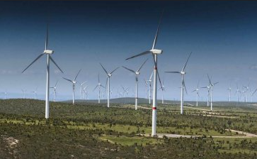
is part of Egypt's ambitious strategy to transition to renewable energy and reduce reliance on fossil fuels. Located in the Red Sea region, known for its strong and consistent winds throughout the year, the project benefits from one of the best
locations in the world for harnessing wind energy. It aligns with Egypt’s Vision 2030, which aims to generate 42% of the country’s electricity from renewable sources by 2035, while promoting sustainable development and environmental protection. The project also reflects Egypt’s commitment to global environmental issues, especially after hosting the COP27 climate conference in 2022.
Fig.15

Advantages:
- Support for Sustainable Tourism: Helps reduce pollution and preserve the natural environment that Sharm El-Sheikh’s tourism industry depends on.
- Local Economic Growth: Creates new job opportunities in construction, maintenance, and operation.
- Ease of Grid Integration: The proximity to urban areas facilitates the connection of generated electricity to the national grid.
Disadvantages:
- High Initial Costs: Requires significant investment in infrastructure and technology.
- Potential Environmental Impact: May affect local wildlife, such as birds and bats, if not carefully planned.
- Investor Hesitation: The project may face challenges in attracting investments due to limited prior experience in the region

II. Generating and defending a solution

Solution and design requirements
In our capstone project, to solve this problem, we must select the most ideal solution. The successful solution must be implemented with any mistakes and should implemented in a creative way. The general requirements that must be in any efficient, effective solution are:
- The amount of productivity and efficiency: the solution must generate at least 0.04 kWh.
- Time Frame: the energy must be generated in 5 minutes or less.
- Storage system: the generated energy must be stored in any storage device to be used anytime.
- Recycled materials: waste materials must be used that can be recycled or used again.
- Design size: The prototype must be designed to be small and portable, with a volume not exceeding 0.5 m³.
- Safety: The project must comply with safety standards.
- Prohibition: Hydrogen, piezoelectric.
These requirements must be fulfilled for our solution to be effective. Now, let's discuss why each of those is required to produce the perfect one:
- It is necessary to produce the required amount of electricity (0.04 kWh) within the specified time of 5 minutes. This is the main solution that we must adhere to, otherwise the project will fail.
- It is necessary to use and recycle wasted materials, and the project must be implemented from recycled or wasted materials to solve the pollution problem facing our nation and turn something useless into something useful.
- All safety rules must be strictly followed in schools, and not done until problems occur.

design requirements
- The device must produce at least 0.04 Whs. within a maximum of 5 minutes.
- The generated energy must be stored in a measurable storage system for later use.
- The use of waste materials in construction is encouraged to promote sustainability.
- The prototype must not exceed 0.5 m³ in volume.
- The energy source must be derived from non-conventional sustainable resources, using one of the following technologies:
    - Micro-sized hydro power station
    - Small solar chimney
    - Innovative vertical wind axis turbine
    - Biofuel
    - Microbiological cells
    - Liquid fuel cells
    - Pumped hydro storage (PHS)

- The storage system must compensate for energy deficiencies due to variability in renewable sources.
- Only Fab Lab tools must be used for construction, no external fabrication services are allowed.
- All school safety rules must be strictly followed, and failure to do so will result in a grade reduction.
- Laboratory equipment must not be removed, and all tests requiring lab tools must be conducted inside the lab.
- The use of piezoelectricity for energy production is not permitted.
- Storing energy in pre-made power banks is not allowed; the storage system must be designed from scratch.
- Hydrogen is strictly prohibited from being used in the prototype.
- If energy is stored in compressed fluids, the pressure must not exceed 2 bars for safety reasons.
Selection of solution
Here we are in Egypt, our country faces many problems that slow down the development and progress of our country. These problems are known as The Egyptian grand challenge, and after research and effort, we have reached a solution to these problems. Egypt is suffering greatly from climate change and its harmful effects on humans and the surrounding environment. This is often due to the continuous use and heavy reliance on non-renewable energy sources, which are typically polluting to the environment and lead to climate changes and pollution.
Solution idea:
After research, we found that renewable energy sources (such as wind turbines, solar energy, and tidal energy) can help eliminate this problem.
Based on our findings, we propose the construction of a Savonius H-Rotor Hybrid Wind Turbine. Due to its reliance on both lift and drag forces, this type of turbine can operate efficiently in all environments and under all conditions.
This type of turbine will have semi-closed sides to help improve airflow and speed up the impeller to do its best work.
Advantages:
- Self-starting at Low Wind Speeds: Thanks to the Savonius rotor, the turbine can start rotating even with low wind speeds without the need for any external motor.
- Higher Efficiency at Stronger Winds: The H-Rotor (which relies on lift force) increases efficiency and rotation speed as the wind speed increases.
- Stable Operation in Different Wind Conditions: Combining Savonius and H-Rotor ensures stable performance whether the wind is weak or strong.
- Suitable for Urban and Residential Areas: Being a Vertical Axis Wind Turbine (VAWT), it doesn’t need to face the wind direction and can operate efficiently in turbulent or changing wind patterns.
- High Safety and Low Noise: The vertical design makes it safer for humans and birds, and it operates with much lower noise compared to traditional horizontal turbines.
- Environmentally Friendly: It uses renewable wind energy, helping to reduce reliance on fossil fuels and lowering carbon emissions.
- Affordable and Accessible Materials: It can be built using simple, widely available materials like wood and plastic pipes, making it low-cost and easy to manufacture.
- Easy Maintenance: Because the components are near the ground, it’s easier and cheaper to maintain compared to large horizontal wind turbines.
- Direct Energy Storage Capability: The produced energy can be stored immediately in lithium batteries, ensuring continuous power supply even when the wind drops.

Selection of Prototype
Our team selected a hybrid Savonius-H rotor vertical axis wind turbine (VAWT) as our prototype. The design combines two types of rotor blades: Savonius (drag-based) and H-rotor (lift-based). This configuration balances startup torque and rotational speed, allowing stable energy production in variableص wind conditions.
The prototype consists of the following key components:
- Rotor Assembly
  - Two curved Savonius blades made from PVC sheets mounted vertically on a central shaft.
  - Three straight H-rotor blades made from acrylic, spaced equally around the same shaft using aluminum arms.
- Support Structure
  - The main shaft is mounted on ball bearings fixed to a metal frame.
  - The entire structure is anchored to a stable wooden base for support and safety.
- Energy Conversion System
  - A high-torque DC motor acts as a generator, converting rotational motion into electricity.
  - The motor is connected to a rectifier circuit and a rechargeable battery for energy storage.
- Measurement Tools
  - A multimeter measures voltage and current output.
  - A tachometer is used to track rotational speed.
The prototype meets our design requirements:
- Energy Output
Designed to generate at least 0.04 kWh under 5 minutes in controlled wind simulation.
- Compact Size
Total volume remains under 0.5 m³ to fit Capstone constraints.
- Eco-Friendly Materials
Reuses waste materials such as PVC, scrap metal, and recycled wood.
- User and Test Friendly
Easily assembled, safe to handle, and fully testable with standard lab tools.

III. Constructing and Testing a Prototype

Materials and methods
Item | Usage | Price | Source | Picture
Water pipe | Make the Savonius rotors | Free | Recycled | 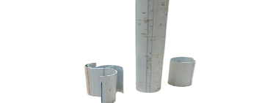
Wood blank | Make the ‘H-rotor’ rotors and the base of the Savonius rotors | Free | Recycled | 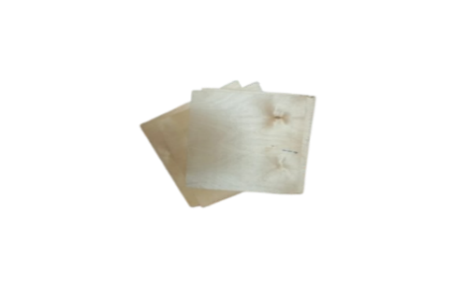
6-volt DC motor generator | The electricity generator | 25 | Electronics store | 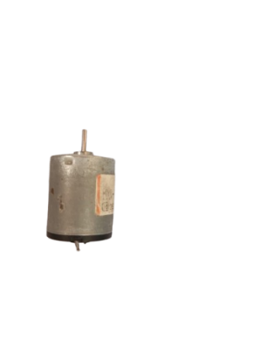
Bike wheel spokes | Connect between savonieus rotors and (H-rotor) | Free | Recycled | 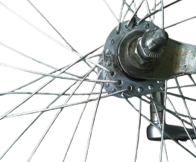
Lithium battery | Storage electricity | Free | Recycled | 
Silicone bone | For the composition in the base to make a Smooth movement | 100 | Recycled | 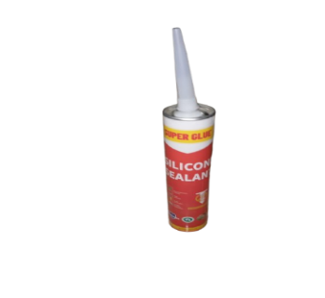
Aerosol can lid | Make the base of the generator | Free | Recycled | 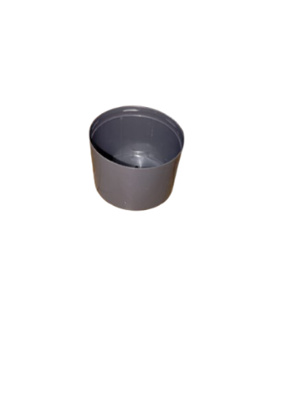

Methods
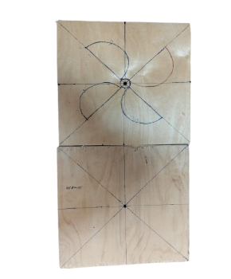
- The construction of the prototype occurred in the
subsequent manner: -
- Determine the texture and the dimensions of
The materials (wood, blanch_ water pipes) and buying them.
Fig16
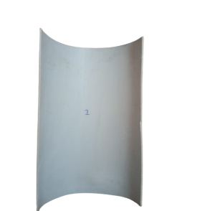
- Cutting the water pipes to make the structure of the Savonius rotors.
- Cutting the wood blank to make the base of the Savonius and market the wood base to determine the right place of the Savonius rotors.
- Cutting the wood blank to make the structure of the (H-rotor) rotors.
Fig17
- Cutting the wood blank to make the base of the prototype.
- Attaching the generator to the base.
Test plan
The design requirements we have chosen to test the prototype:
There are a lot of things that we should test to outfit What is required from in the design requirements in the challenge
The device must be capable of generating at least 0.04 kilowatt-second (kWs) of electrical energy within a maximum of five minutes.
The generated energy must be stored in a suitable energy storage device, such as a battery, to be used at any later time.
The device should preferably be constructed using recycled or waste materials, in order to promote sustainability and reduce overall costs.
The total volume of the prototype must not exceed 0.5 cubic meters (m³), ensuring ease of transportation, storage, and suitability for indoor or educational environments.
The steps we follow it to test our prototype:
Safety Rules: using a coat, gloves and glasses is very important when testing your prototype.
- •Water pipes will be used to manufacture the blades, with each blade being 25 cm in length.
- identical blades will be manually produced, ensuring they are shaped to optimally capture wind energy.
- The blades will be glued using lithium glue onto a plywood board.
- The blades will be evenly spaced to ensure perfect balance during the rotation of the turbine.
- After securing the blades onto the plywood board, the motor or generator (alternator) will be installed to convert the rotational motion generated by the wind into electrical energy.
- Adhering to safety protocols by wearing safety equipment.
- Experiment with the prototype output (40 joules or less) at the specific time.
- Use a multimeter to measure volts and amperes and a stopwatch to measure the time.
- Use a law to measure joules in seconds.
- Repeating the test multiple times.
- Noting down the results of the tes
We used some tools to help us in data collection as:
- Stopwatch to Calculate the time.
Measuring tape to Measure project’s dimensions.
The safety precautions:
Item | Usage | Picture
Lab coat | To protect the body of the person working. | 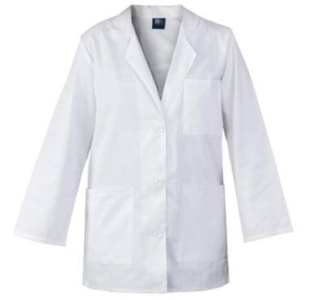
Latex gloves | To protect against the dirt and microbes that the person working on the project might get exposed to. | 
Goggles | To protect the eyes of the person. | 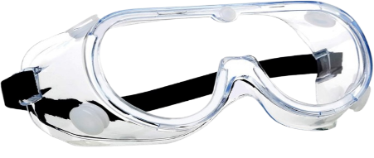

Data collection: -
Tool | Usage | Images
Multimeter | Accurately measuring the deflection and the length of prototype components | 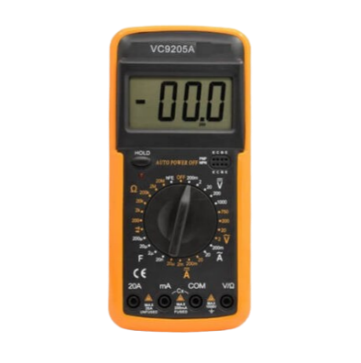
Stopwatch | Accurately measuring the amount of time the prototype takes to open | 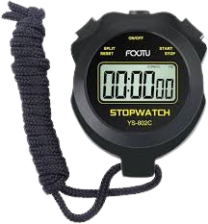

Results
The negative results:
- The turbine showed unstable rotation in low wind speeds, which reduced energy output.
- Blade alignment issues caused mechanical imbalance. The generator efficiency dropped due to friction in the shaft.
Positive result: - The opposite graphs and tables represent the positive result

1-Graph between Electric current intensity and Time
Time (s)\ | I (Ampere)
30 s | 0.046 ± 0.01A
60 s | 0.049 ±0.01A
90 s | 0.047 ±0.01A
120 s | 0.051 ±0.01A
150 s | 0.05 ±0.01A
180 s | 0.046 ±0.01A
210 s | 0.042 ±0.01A
240 s | 0.044 ±0.01A
270 s | 0.046 ±0.01A
300 s | 0.041 ±0.01A

Table 1
Graph 5

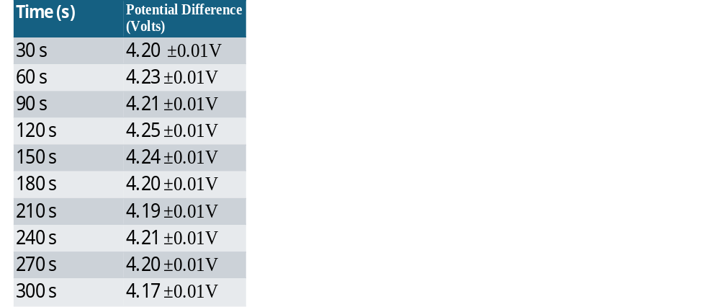
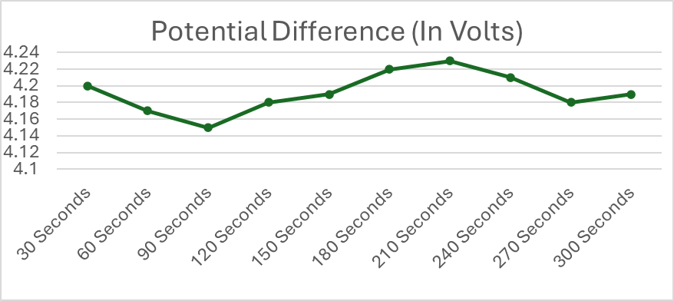
2-Graph between Potential Difference and Time

Table 2
Graph 6

3-Graph between Energy produced and Time
Time (s) | Energy(Joules)
30 s | 5.79 ± 0.01J
60 s | 11.92 ± 0.01J
90 s | 17.77 ± 0.01J
120 s | 24.17 ± 0.01J
150 s | 30.46 ± 0.01J
180 s | 36.28 ± 0.01J
210 s | 41.61 ±0.01J
240 s | 47.17 ± 0.01J
270 s | 52.94 ± 0.01J
300 s | 58.09 ± 0.01J

Table 3
Graph 7

IV. Evaluation,Reflection, Recommendations Analysis and Discussion

Analysis and Discussion
There are numerous Grand Challenges facing Egypt, one of which is the extensive use of non-renewable sources of energy. This worsens climate change, rises in air pollution, and undermines the health of the public, particularly in densely populated cities, as shown in Graph 1. From scientific studies, a transition to renewable energy substantially reduces greenhouse emissions and improves air quality.
our project meets these issues squarely by promoting the use of clean, renewable sources of energy such as solar and wind energy. By reducing the consumption of fossil fuels, the project reduces carbon emissions, minimizes the effects of climate change, and promotes environmental sustainability. It also contributes to economic development by creating jobs in the renewable energy sector and catalyzing a shift towards a green economy. By its scientific and sustainable nature, the project suggests a practical solution for Egypt's energy and environmental issues, leading towards long-term national resilience.
To fix our negative results, we reinforced the mounting structure using tighter joints and additional support brackets from recycled aluminum parts. Blade alignment was corrected through repeated manual adjustments and angle re-checks using a protractor. To reduce vibration, we rebalanced the rotor by adjusting blade weights. Electrical issues were fixed by re-soldering loose wires and using stronger insulation tape to prevent disconnection. We shortened wire lengths between the generator and storage unit to reduce energy loss. For wind direction changes, we tested the system in a controlled position to maintain optimal facing, improving overall stability and minimizing rotation interruptions during variable wind conditions.
This project is based on a Hybrid Vertical Axis Wind Turbine (VAWT) that combines a Savonius rotor and an H-Rotor. The Savonius self-starting and reliable in weak conditions. As wind speed increases, the H-Rotor, designed with airfoil-shaped blades, generates lift force following Bernoulli’s principle, boosting rotational speed and improving efficiency.
We specifically chose to combine these two rotors because each addresses a different wind condition: the Savonius ensures early motion at low speeds, while the H-Rotor significantly enhances energy production at higher speeds.
This hybrid mechanism guarantees continuous operation and better adaptability to varying environmental conditions.
The generated mechanical energy from the rotating shaft is converted into electrical energy through a generator, then stored in a lithium battery for consistent use. Wooden side panels also help to direct and concentrate airflow onto the blades, improving overall performance. By merging drag-based and lift-based technologies, the turbine maximizes energy capture and provides a sustainable, eco-friendly solution.
Features of our prototype:
- Self-Starting Capability: Thanks to the Savonius rotor design, the turbine can start rotating even at low wind speeds without requiring external force.
- High Efficiency at Various Wind Speeds: The H-Rotor (lift-based design) enhances rotational speed and energy output as the wind speed increases, making the system highly adaptable.
- Environmentally Friendly: The use of renewable wind energy reduces reliance on fossil fuels and decreases carbon emissions.
- Energy Storage Capability: The system includes a lithium battery that stores generated electricity, allowing for continuous energy use even when the wind drops.
However, the prototype suffers from a few drawbacks, including :
- Visual organization can be enhanced: The current design prioritizes functionality over appearance; future versions could focus more on creating a cleaner and more aesthetically organized structure.
- Stronger stabilization is needed: At higher wind speeds, the prototype may require a heavier or more reinforced base to ensure complete stability.

The evaluation of the hybrid turbine’s performance relied on scientific laws to accurately determine its Lift and Drag force, power generation, operational efficiency, and kinetic energy:
$$P=\frac{1}{2}ρ×A×v^{3}C_{P}$$
𝑃 represents the power input; 1/2 is the constant from the kinetic energy formula 𝜌 is the air density, 𝐴 is the swept area covered by the turbine blades,𝑣³ shows the cubic relationship of fluid velocity to power (indicating that power increases significantly with higher speeds); and 𝐶𝑃 is the power coefficient, representing the efficiency of converting fluid energy into mechanical energy.
In a simulation where the wind velocity is 11 m/s and the area that the air attraction it is 1.48$m^{2}$ and the value of C(actual power division by wind power)is 0.33 after
a simulation the power = 0.0462 watt`
The opposite graph represent the Exponential relation between wind velocity and power generation.
.

Graph 8
$$\frac{0.194}{0.462}*100=41.99\%$$
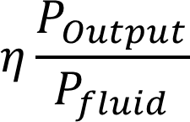
Efficiency tells us how good the turbine is at turning wind energy into electricity. We compare the real output with the total energy the wind could give. Perfect efficiency is impossible, but the closer we get to it, the better the design is.(Where Actual Power Output: The real mechanical or electrical energy generated by the turbine, Available Wind Power: The total kinetic energy carried by the wind passing through the turbine's swept area)
$kE=\frac{1}{2}mv^{2}= \frac{1}{2}×1.81×{11}^{2}$=109.5joules

The kinetic energy law is very important because our turbine operates by converting wind energy into mechanical energy and then into electrical energy. Energy Power tells you how much energy the wind carries before it reaches the turbine . Once we know the power the wind is carrying, we can compare it to your actual output and adjust the turbine more precisely.(where m is mass of air passing through the turbine in Kg, v is velocity of the wind m/s
where C is dimensionless numbers that represent how effectively a body generates lift or drag, depending on its shape and how air flows over it.
$$F_{l/D}=\frac{1}{2}ρ×v^{2}×A×C_{l}/D$$

Drag Force is the force that acts in the same direction as the wind flow. It is caused by the air pushing directly against the surface of the turbine blades as the wind moves and Lift Force in Wind Turbines is the force generated due to the pressure difference between the two sides of a turbine blade as air flows at different speeds over each side. It is the main force used to rotate the turbine blades . Savonius rotor uses drag force to start rotation even at low wind speeds.in In a simulation where the wind velocity is 11 m/s and the area that the air attraction it is 1.48$m^{2}$ and the value of CL is 1.5 and the value of CD is 3.00)according to the physical references and the shape of the blades)
$${ F}_{\overline{L}}=\frac{1}{2}×1.225×{11}^{2}×1.48×1.5=53.4 N (for H-rotor turbine)$$

$$F_{D}=\frac{1}{2}×1.225×{11}^{2}×1.48×3=487.01 N(savonius)$$

The storage system
The energy generated by the hybrid turbine is stored in lithium-ion batteries. These batteries are lightweight, have high energy density, and can store a large amount of energy in a small space. They also have a long lifespan and fast charging capabilities, making them ideal for renewable energy systems. Using lithium batteries ensures stable power supply even when wind conditions change

Conclusion
We therefore concluded that after subjecting our test data to testing, our hybrid Savonius-H-Rotor wind turbine model met all the required Capstone design specifications. It was producing consistent electric output at low winds, it met the size dimension specifications, and its main composition consisted of recycled, local, and readily accessible material. Efficiency tells us how good the turbine turns wind energy into electricity. We compare the real output with the total energy the wind could give. Perfect efficiency is impossible, but the closer we get to it, the better the design is, and total efficiency is 41.99 %. The design consisted of a very simple, trustworthy energy storage system, and its structural configuration withstood over tens of tests. Balance and function adjustments were completed after some testing. Proudly borrowing lessons from the experience of traditional vertical-axis wind turbines, our design boasts the good self-starting characteristic of the Savonius rotor and the high-speed efficiency of the H-Rotor. This allowed our design to function at its best in mixed conditions without requiring complex components. Compared to other single-type rotor designs before it, our hybrid was more efficient, easier to construct, and field deployable. The design is sustainable, affordable, and useful.
It shows clear improvement in usability, sustainability, and dependability, and is a good example of small-scale renewable energy technology systems. Our project uses the Capstone's focus on innovation and environmental responsibility well.
It also provided us with real hands-on experience for addressing real engineering issues, proving that clean energy can be harnessed by simple hardware, collaboration, and creative design

Recommendations
Innovation is a continuous process, and there is always room to implement new improvements and enhancements to ensure the design keeps pace with the rapid evolution of modern technology. Some of the recommendations or modifications:
- Try to use an Arduino system to have more control over our prototype.
- Use a material stronger than (our material), and we suggest using this material (wood - blanch - water pipes - Part of the clothes hanger).
- Try to do more safety in our project, for example, put a box near the project and put the wires in it.
- Use a Voltage Regulator to have more control over the prototype. Try to use the Anemometer sensor in the project to measure wind speed.
- Improving Blade Design for Better Aerodynamics.
- Include a Simple Braking Mechanism.
- Improving Blade Design for Better Aerodynamics.
- Include a Simple Braking Mechanism.

Learning Outcomes
Science is an interconnected system where physics, chemistry, biology, computer science, and mathematics combine to create real solutions for real-world challenges. Therefore, we seek to use the scientific concepts we studied this year in our project, which were:
(ES.1.10) Harnessing wind energy with vertical axis wind turbines (VAWT), such as H-rotor and Savonius, is a renewable source of electricity. Based on this same idea, the project aims to harness wind as an alternative energy source.
(ES. 1. 09 & ES. 1. 13)Innovative solutions for pollution reduction — wind turbines reduce Egypt’s carbon footprint and help to create a clean tech employment base “Energy resource usage in Egypt versus other states.
(ES.1.08) Ore Minerals & Rare Earths are relevant if you discuss turbine material (magnets, conductors, etc.).
(PH.1.08) The wind generates pressure differentials across turbine blades. Those differences create lift and torque, which rotate the blades and produce power. This is the basic operating principle of both Darrius and H-rotor turbines.
(PH.1.09) This curvature of the blades increases the velocity of the wind as it flows along the surface of the blade, creating low-pressure regions due to Bernoulli's principle, which creates lift. The lift generates the rotation of vertical-axis blades that help the H-rotor turbines.
(PH.1.10) First Law of Thermodynamics turbine just changes kinetic energy of the wind into electrical energy. This law allows the calculation of energy input and energy output and can be used to test system efficiency.
(PH.1.08) Museum of Natural Science Global learning Exhibit, Houston, TX > Pascal’s Principle in the Model Pascal’s Principle assists in modeling air pressure propagation on the surface of the turbine.
(MA.1.07) Quadratic function Quadratic function Wind turbine output (e.g. voltage or RPM) can be modeled as a quadratic function for wind speed.
(MA.1.07)Parabola (focus, directrix) Blade path motion (Darrieus-type) tends to follow curved motion associated with moving on parabolic coordinate areas.

(MA.1.07) Related roots & coefficients Help to find max/min of output, Useful for maximum power generation.
(MA.1.08) Wear and Tear means degradation over time (in the power generation relative to wind speed) will follow a nonlinear curve: Exponential growth & decay Models report link.
(MA.1.08) Logarithmic functions Useful in data analysis when evaluating large/small ranges (ex, decibels (dB) for wind, sound).
(ME.1.06) Newton’s 1st Law & Translational Equilibrium Use these methods to test if the H-rotor - Savonius designs stay in rotational equilibrium at high winds.
(ME.1.09) Circular Motion Given that Sevanios has a greater rotor radius than Darios, determine which model produces more power (at equal wind speed) based on the principles of centripetal motion.
(BI.1.9) to (BI.1.11) Photosynthesis & Energy Conversion Energy Transduction Efficiency Comparison
Photosynthesis (1–2% efficiency) vs. wind turbines (30–50% efficiency)
Draw on the leaf structures’ adaptations (stomata, xylems etc.) to inform the design of the blades to minimize drag (e.g. how leaves reduce water loss)
(CH.1.09) How we choose the materials that used in construction the prototype based on texture to achieve the best handling of air according to the concepts of Aerodynamics

Citation
1- A. Ghanem and M. Salah Elsobki. (2024). Wind power development in Egypt: Historical overview, current status, and future prospects. Athens Journal of Mediterranean Studies. Athens, Greece. https://www.athensjournals.gr/mediterranean/2024-6262-AJMS-Ghanem-04.pdf
2- Chandler, D. L. (2024). MIT engineers' new theory could improve the design and operation of wind farms. MIT News. Massachusetts, United States. https://news.mit.edu/2024/new-theory-could-improve-design-and-operation-wind-farms-0821
3- El-Nenaey, K. M., Eldrainy, Y. A., Eissa, A. A., & Kassab, S. Z. (2020). Performance evaluation of hybrid vertical axis wind turbine. Thermal & Fluids Analysis Workshop (TFAWS). Alabama, United States. https://tfaws.nasa.gov/wp-content/uploads/TFAWS2020-ID-512-El-Nenaey-Paper.pdf
4- Giguère, P., & Selig, M. S. (2000). Blade geometry optimization for the design of wind turbine rotors. AIAA Paper No. 2000-0045. Nevada, United States.
https://m-selig.ae.Illinois.edu/pubs/GiguereSelig-2000-AIAA-2000-0045.pdf
5- National Renewable Energy Laboratory. (2025). NREL invites industry, academia to help advance large wind turbine designs. Golden, Colorado, USA. https://www2.nrel.gov/news/detail/program/2025/nrel-invites-industry-academia-to-help-advance-large-wind-turbine-aerodynamics
6- U.S. Department of Energy. (2021). Small Wind Guidebook. WIND Exchange. Washington, D.C., USA. https://windexchange.energy.gov/small-wind-guidebook
7- U.S. Department of Energy. (2023). Wind energy basics. Office of Energy Efficiency & Renewable Energy. Washington, D.C., United States
https://www.energy.gov/eere/wind/wind-energy-basics
8- U.S. Energy Information Administration. (2024, August 13). Country analysis brief: Egypt. U.S. Department of Energy. Washington, D.C., United States. https://www.eia.gov/international/content/analysis/countries_long/Egypt/pdf/Egypt.pdf

9- U.S. Energy Information Administration (EIA). (2024). Country analysis brief: Egypt. U.S. Department of Energy. Washington, D.C., USA. https://www.eia.gov/international/analysis/country/EGY
10-Youssef, K. M. (2016). Optimization of two and three rotor Savonius wind turbine. Ain Shams University. Pennsylvania, USA. https://citeseerx.ist.psu.edu/document?doi=976c0a31e4e087268433125aec5e0f423db79370

